

UNIVERSITY OF AZAD JAMMU & KASHMIR
Department of Software Engineering
Software Configuration Management Technologies (SCMT)

Lab No.8

Submitted by | - Name: Rizwan Ali  - Roll No: 2025-SET-40
Submitted To | - Eng. Fahad Nisar
Degree Program | - BSc Software Engineering Technology
Submission Date | - 8 June 2026

Lab Objective: Pulling Remote Changes from GitHub

Objective
The objective of this lab was to make changes directly on GitHub and then synchronize those changes with the local repository. This task helped in understanding how remote repository updates can be fetched and integrated into a local working copy using Git commands.

Step 1: Make a Change Directly on GitHub
In this step, I opened my GitHub repository and switched to the main branch. I created a new file named remote-change.txt directly through the GitHub web interface and added sample content to it. After entering an appropriate commit message, I committed the file to the remote repository.
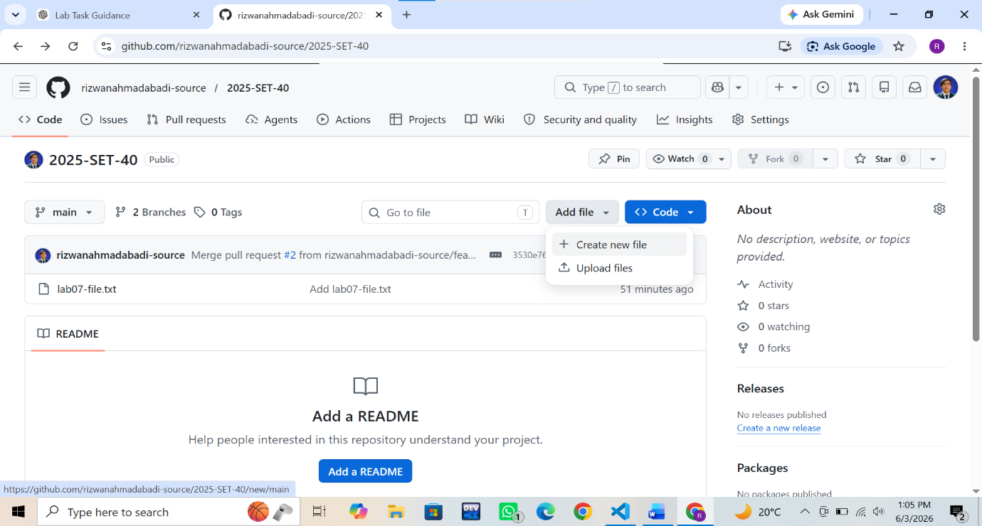

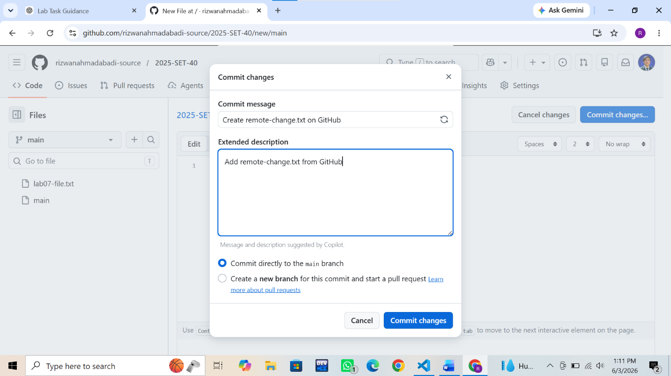
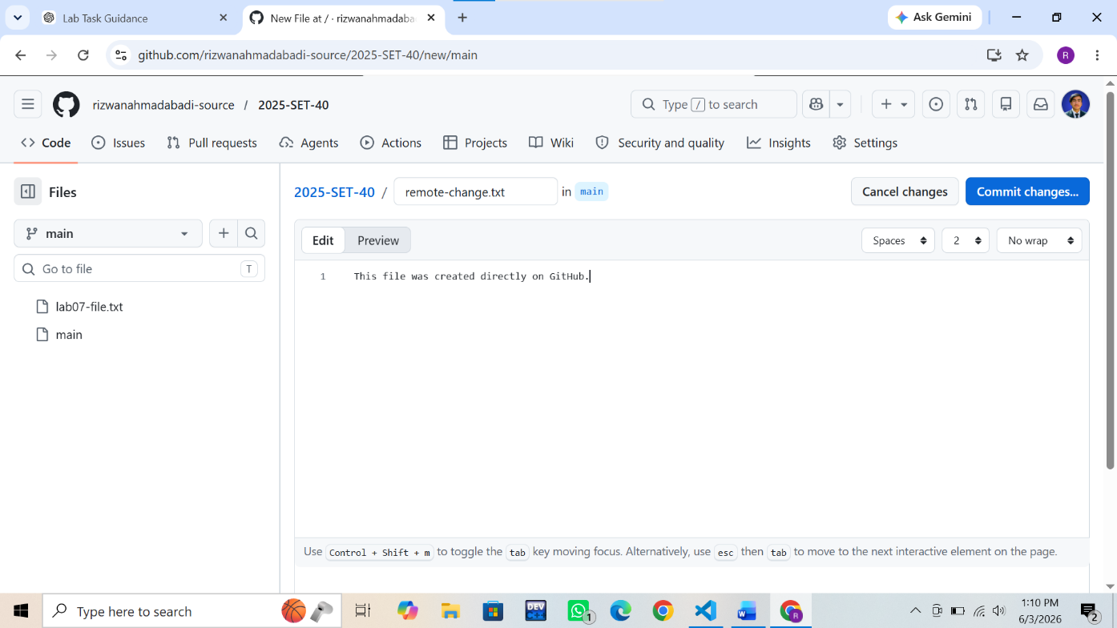
Step 2: Check the Local Repository Before Pulling & Pull the Remote Changes
In this step, I opened the local repository in Visual Studio Code and verified that the newly created file was not available in the local copy. I then switched to the main branch to prepare for fetching the latest changes from GitHub. And I synchronized my local repository with the remote GitHub repository. After confirming that I was on the main branch, I executed the pull command to download GitHub. The command successfully fetched and updated the local repository with the newly added file.

Commands Used
- git checkout main
- git checkout main
- git pull origin main
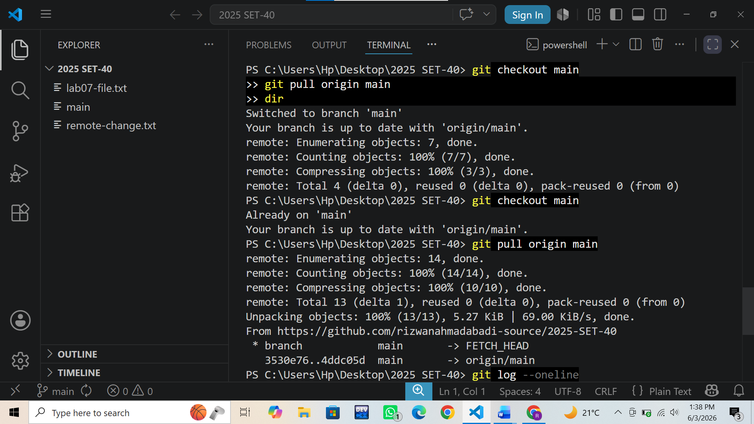

Step 4: Verify the Change Locally
In this step, I verified that the remote changes were successfully reflected in my local repository. The newly added file, remote-change.txt, appeared in the VS Code Explorer after performing the pull operation. I also checked the commit history using the git log --oneline command and confirmed that the commit created on GitHub was present in the local repository history. This verified that both the local and remote repositories were synchronized successfully.
Commands Used
- git log --oneline

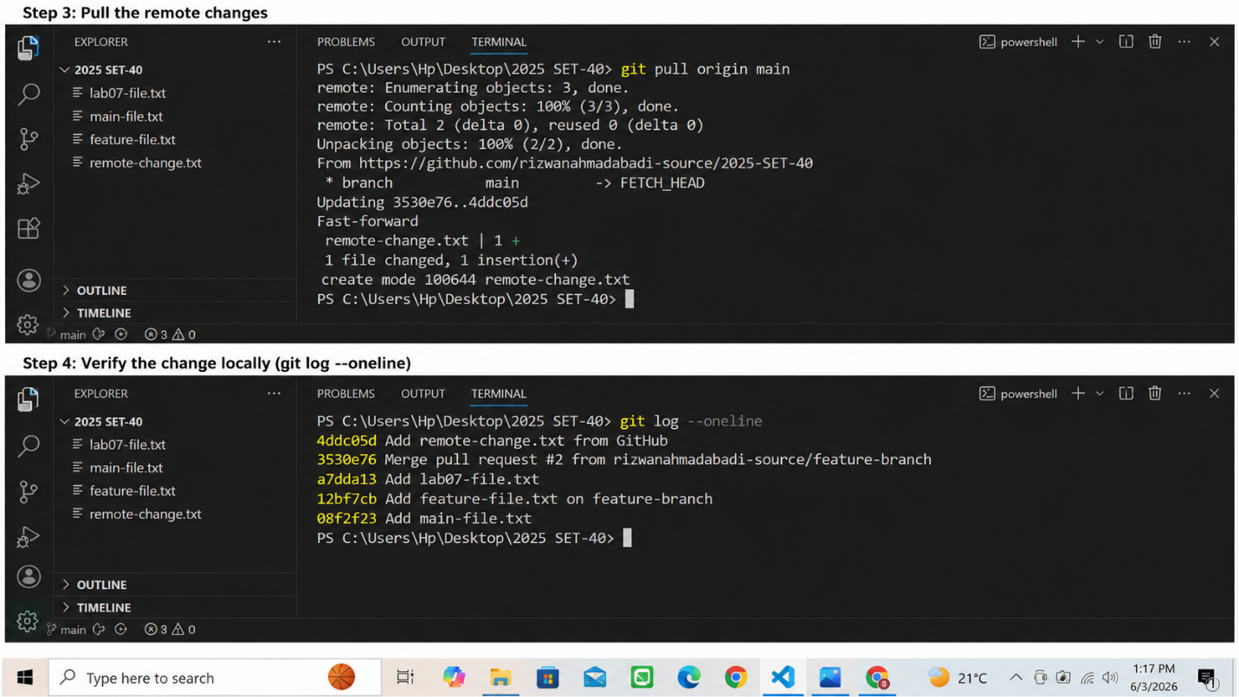

Conclusion
This lab provided practical experience in synchronizing a local Git repository with changes made directly on GitHub. I learned how to pull remote updates into a local repository, verify commit history, and ensure consistency between local and remote repositories. The exercise enhanced my understanding of GitHub collaboration workflows and reinforced the importance of keeping local and remote repositories synchronized during software development.

